Task01::

Given code manages collision using linkedlist chaining at the node index.
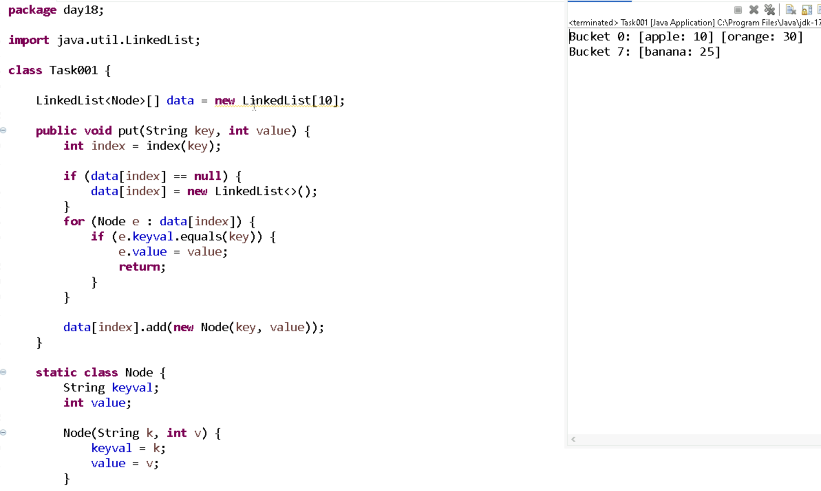

Task002::
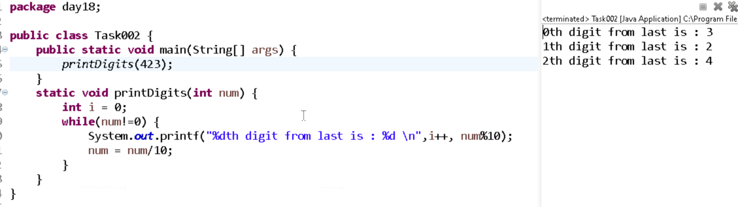

Task003::
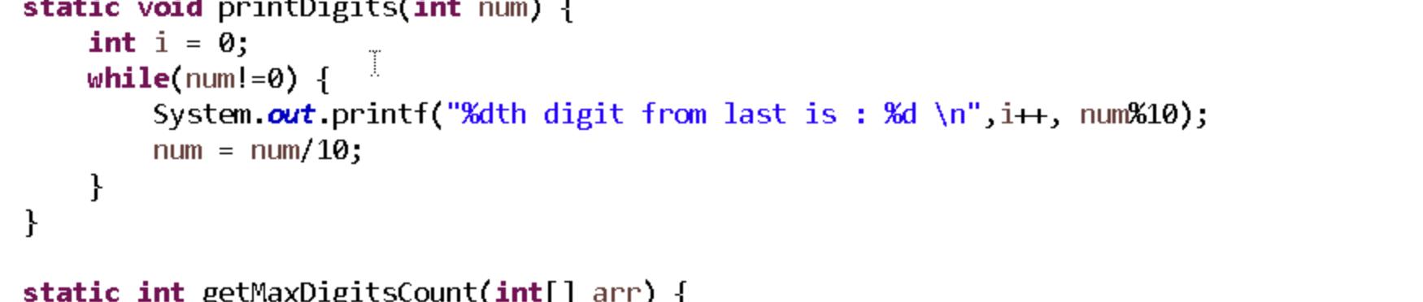

Task004::
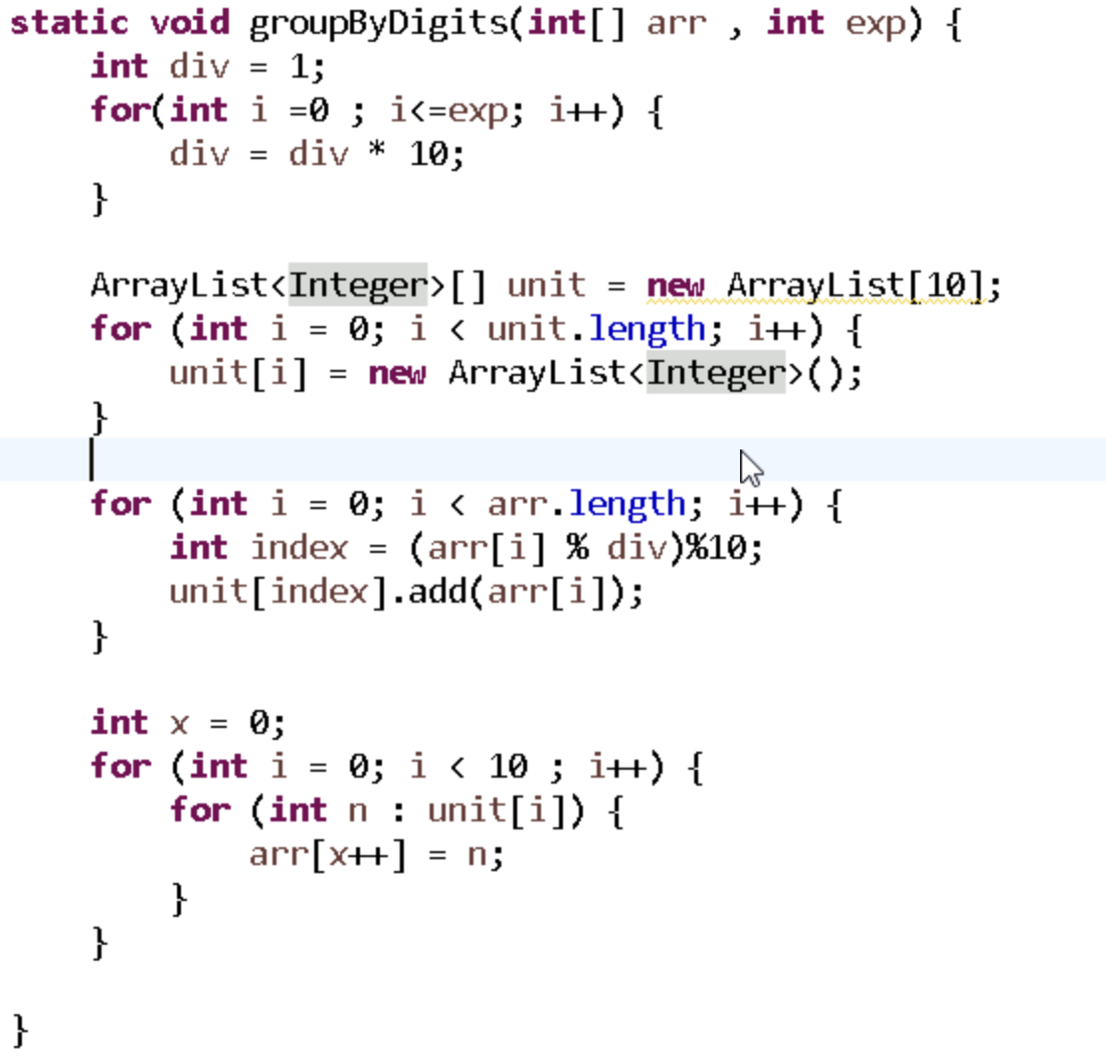
Task005::

Find the largest number in the array
→ This tells us how many digit places we need to sort (units, tens, hundreds, etc.).
Start from the rightmost digit (the units place).
Group all numbers based on their digit at that position
→ Put numbers with the same digit into the same bucket (0–9).
Pull numbers out of the buckets in order (0 to 9)
→ This gives a partially sorted list based on that digit.
Repeat steps 3–4 for the next digit to the left
→ Go to tens place, then hundreds, etc.
After all digits are processed, the array is sorted.

Task006::

  - Function getMaxDigitCount(array):
    - max = array[0]
    - For each number in array:
    - If number > max:
    - max = number

    - count = 0
    - While max > 0:
    - max = max / 10
    - count = count + 1

    - Return count
  - Function groupByDigits(array, digitPlace):
    - exp = 10 ^ (digitPlace - 1) // For 1st digitPlace, exp = 1

    - Create bucket[10] as list of empty lists

    - For each number in array:
    - digit = (number / exp) % 10
    - Add number to bucket[digit]

    - index = 0
    - For i from 0 to 9:
    - For each num in bucket[i]:
    - array[index] = num
    - index = index + 1
  - Function radixSort(array):
    - maxDigits = getMaxDigitCount(array)

    - For i from 1 to maxDigits:
    - groupByDigits(array, i)

Task007:
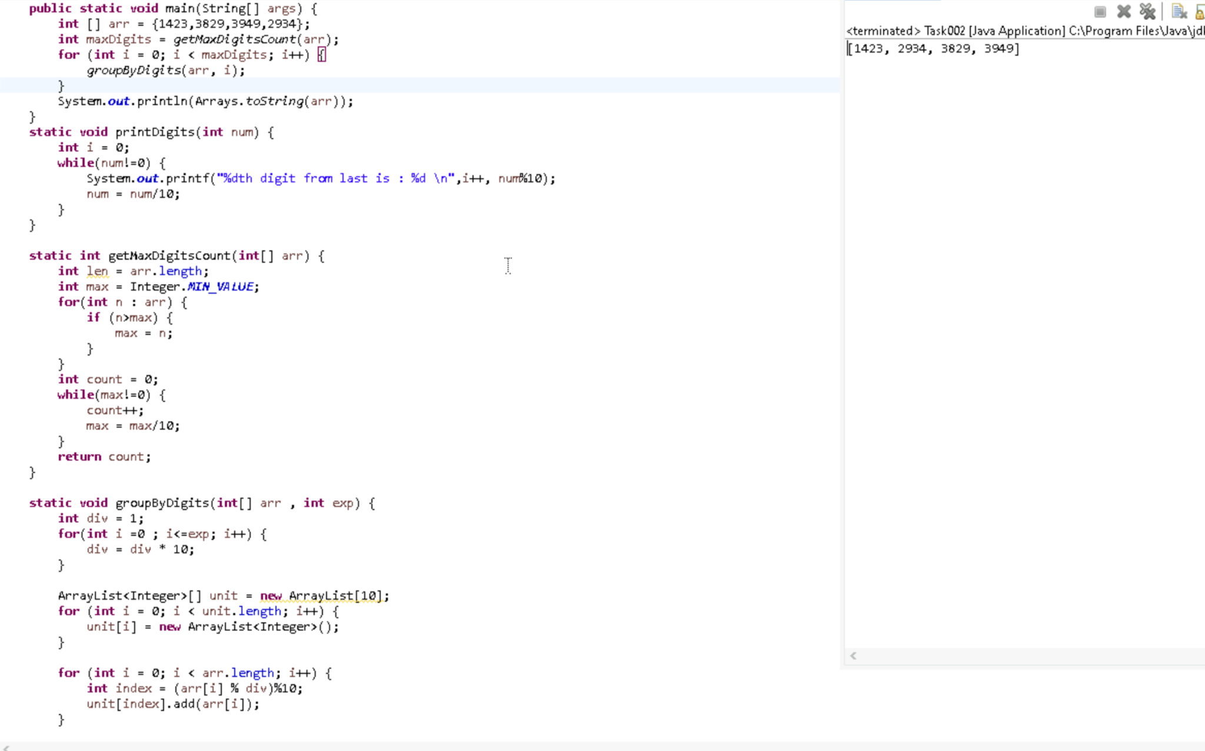

Task008:
it achieve same result but emphasizes on recursive style using the same level-order logic with explicit queue management?

Task009::
Memoization is storing the results of already-solved subproblems to avoid recalculating them.
It speeds up recursive solutions like Fibonacci by reusing answers.

Task010::
Dynamic Programming is solving a big problem by combining solutions of smaller subproblems.
It avoids repeated work using arrays or tables (bottom-up approach).

Task011::
int fibonacci(int n) {
if (n <= 1) return n;
int a = 0, b = 1;
for (int i = 2; i <= n; i++) {
int temp = a + b;
a = b;
b = temp;
}
return b;
}

This is called Bottom-Up Dynamic Programming with Space Optimization.
It’s just a more efficient version of the classic dp[] approach.
Task 17::
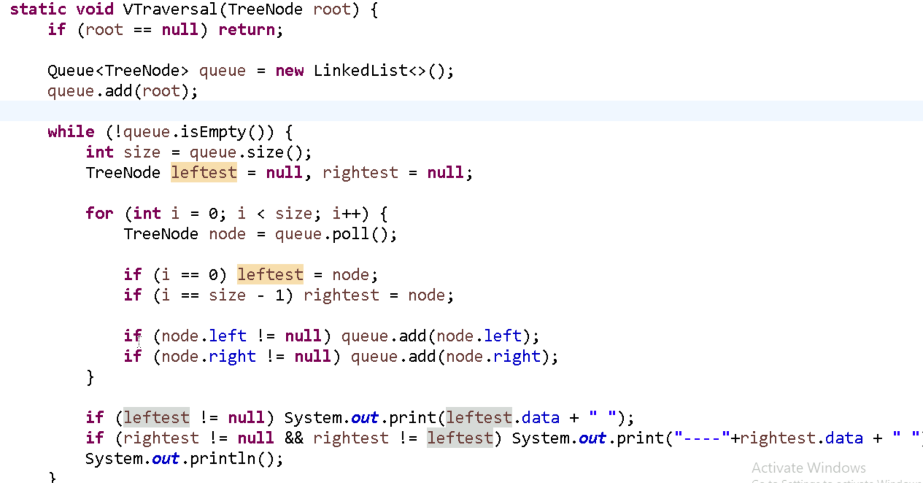
Task18::
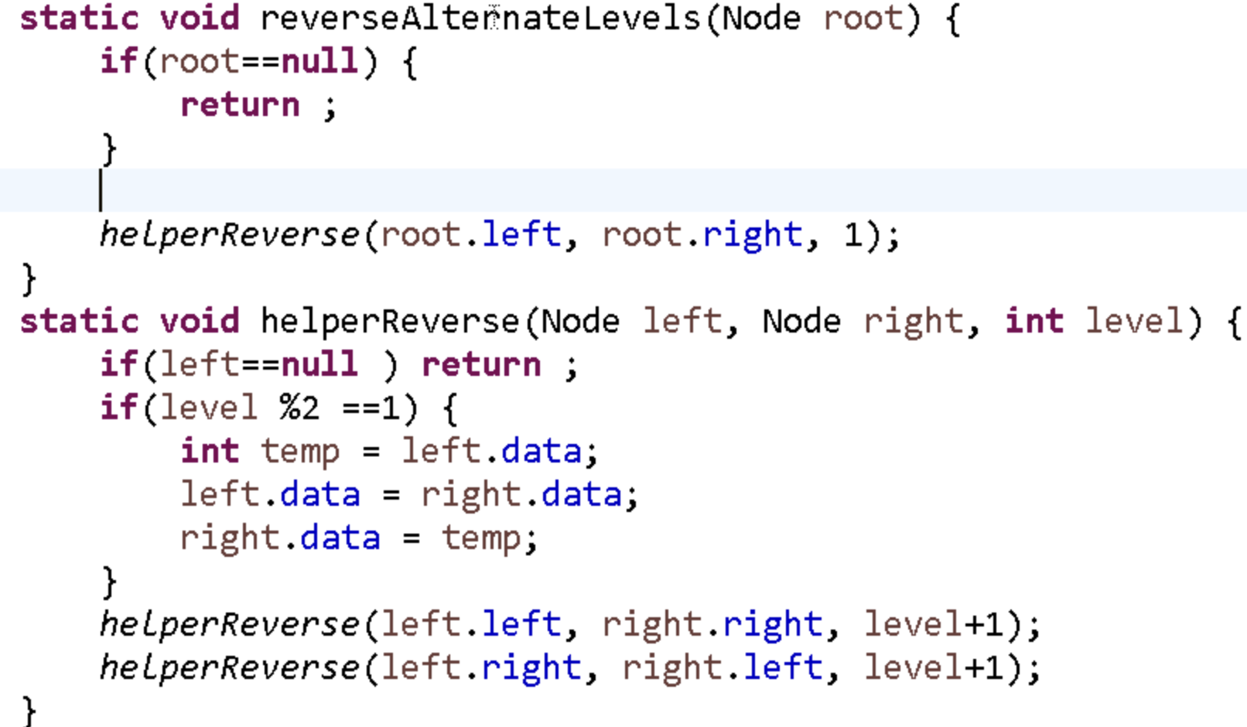

Task19::
